Ideation Phase

Define the Problem Statements

Date | 02 November 2025
Team ID | NM2025TMID00163
Project Name | Laptop Request Catalog Item
Maximum Marks | 2 Marks

Customer Problem Statement Template:

Employees currently face delays and confusion when requesting laptops through manual or unstructured processes. The lack of an automated system leads to data errors, inconsistent approvals, and poor tracking of requests.
To resolve this, a ServiceNow-based Laptop Request Catalog Item is needed to streamline the process, apply dynamic form behaviors, and ensure accurate data capture. This will improve efficiency, transparency, and governance in handling laptop requests across the organization.

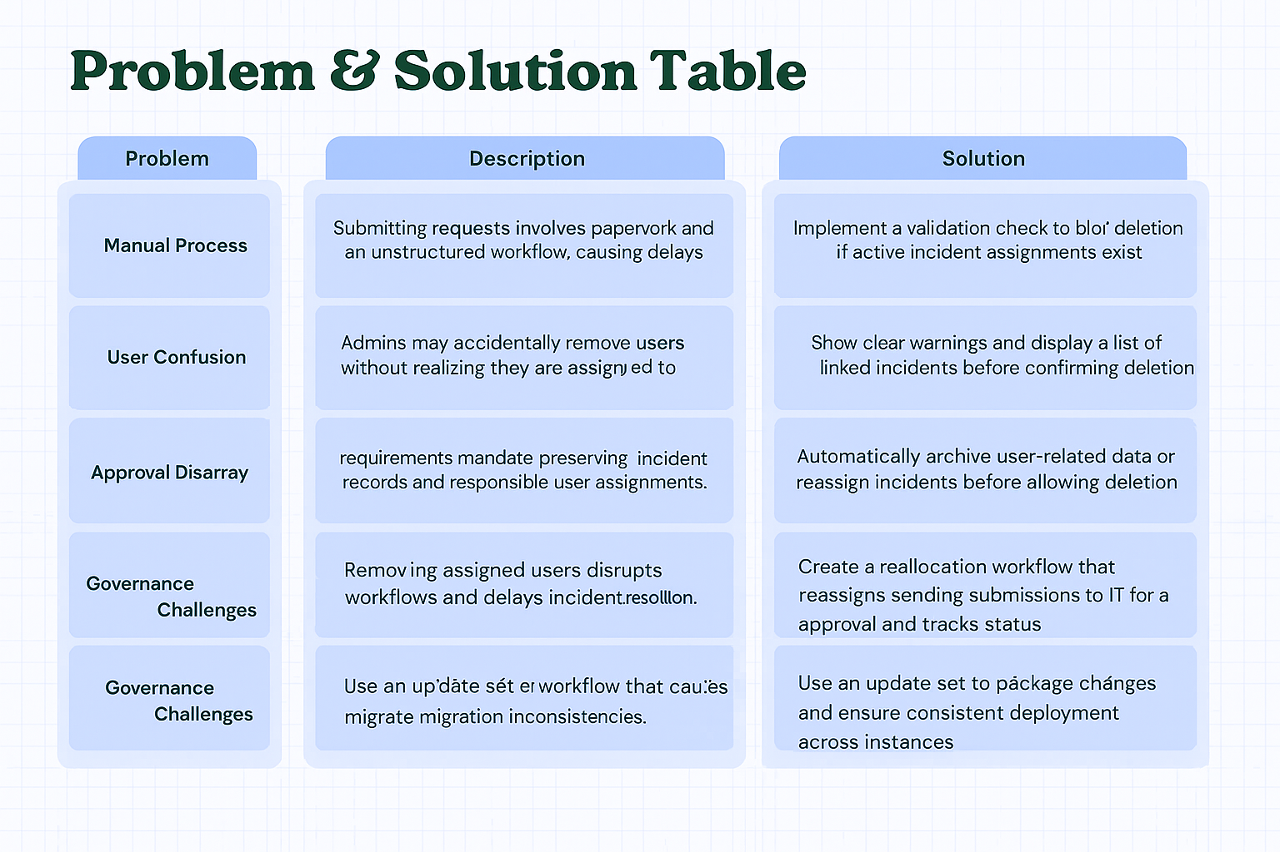

Example:

Problem  Statement (PS) | I am  (Customer) | I’m trying to | But | Because | Which makes me feel
PS-1 | An Employee | Request a laptop for work | The form process is manual and confusing | It lacks a clear structure and guidance for required details | Frustrated and unsure if my request is complete
PS-2 | An IT Administrator | Approve and track laptop requests | Requests come through different channels | There’s no centralized catalog item or automated record | Overwhelmed and unable to manage requests efficiently

⬛✓ Problem Statement PS 1:
As an employee, I am trying to request a laptop for my work, but the process is manual and unclear. There is no dynamic guidance on what details to fill, such as justification or accessories required. This makes me feel frustrated and uncertain if my request will be approved on time.
I need a simpler and guided digital form within ServiceNow that captures all details accurately and helps streamline the approval process.

⬛✓ Problem Statement PS 2:
As an IT administrator, I am trying to review and approve laptop requests, but they are scattered across multiple sources. Since there is no centralized catalog item or automated process, tracking requests becomes difficult and time-consuming. This makes me feel overwhelmed and reduces efficiency.
A unified ServiceNow catalog item would help centralize requests, ensure data accuracy, and simplify the approval and fulfillment workflow.

